# **A MINI PROJECT REPORT**

# **ON**

**MAINS OPERATED LED LIGHT CIRCUIT**

**Submitted in partial fulfillment of the requirements for the**

**award of**

**BACHELOR OF TECHNOLOGY IN**

**ELECTRONICS AND COMMUNICATION ENGINEERING BY MANCHI TEJA SAI**

**(19761A0496)**



**UNDER THE GUIDENCE OF**

**Dr.B.Siva Hari Prasad**

**Associate Professor**

**DEPARTMENT OF ELECTRONICS AND COMMUNICATION ENGINEERING**

**LAKIREDDY BALI REDDY COLLEGE OF ENGINEERING (AUTONOMOUS)**

L.B. REDDY Nagar, Mylavaram-521230,

Approved by AICTE, New Delhi, Affiliated to JNTU, Kakinada, Accredited by NAAC & NBA

Certified by ISO 9001-2015,

(2021-2022)

**LAKIREDDY BALI REDDY COLLEGE OF ENGINEERING (AUTONOMOUS)**

L.B. Reddy Nagar, Mylavaram-521230,

Approved by AICTE, New Delhi, Affiliated to JNTU, Kakinada, Accredited by NAAC & NBA

Certified by ISO 9001-2015

**DEPARTMENT OF ELECTRONICS AND COMMUNICATION ENGINEERING**



**CERTIFICATE**

This is to certify that Mini Project entitled “**MAINS OPERATED LED LIGHT CIRCUIT”** is a bonafide work done and submitted by **MANCHI TEJASAI(19761A0496)** in partial fulfillment of requirement for the award of Bachelor of Technology in Electronics and Communication Engineering at LAKIREDDY BALI REDDY COLLEGE OF ENGINEERING,

MYLAVARAM during the year 2021-2022.

**PROJECT GUIDE HEAD OF THE DEPARTMENT**

Dr.B.Siva Hari Prasad Dr. Y. Amar Babu

Associate Professor Professor

# **ACKNOWLEDGEMENT**

The Satisfaction that accompanies that the successful completion of any task would be incomplete without the mention of people whose ceaseless co- operation made it possible, whose constant guidance and encouragement crown all efforts with success.

I humbly express my thanks to our Principal **Dr**.**K.Appa Rao** for extending his support and for providing us with an environment to complete Mini Project course successfully.

I deeply indebted to our Head of Department **Dr.Y Amar Babu,** who modeled us both technically and morally for achieving greater success in life.

I extremely thankful to my supervisor **Dr.B.Siva Hari Prasad**, Department of Electronics and Communication Engineering, for his/her excellence guidance, timely and valuable suggestions and encouragement that enabled the success of the Mini Project.

I would like to thank all the teaching and non-teaching staff members of Electronics and communication Engineering, who have extended their full co- operation during the course of my mini project.

I would like to express my heart full thanks to our parents for their unflinching support and constant encouragement throughout the period of my Mini Project work for making it a successful one.

I thank all my friends who helped me sharing knowledge and by providing material to complete the Mini Project in time.

**MANCHI TEJASAI**

**(19761A0496)**

**INDEX**

|  |  |
| --- | --- |
| **CONTENTS** | **Page No.** |
| **Abstract** | **I** |
| **List of Components** | **ii** |
| **Chapter 1: INTRODUCTION** | 01 |
| **Chapter 2: Description About The Components** | 02 |
| 2.1 BRIDGE RECTIFIER | 03 |
| 2.2 RESISTORS | 04 |
| 2.3 LED’S | 05 |
| 2.4 CAPACITORS  2.5 BREAD BOARD  2.6 CONNECTING WIRES | 06  07  08 |
|  |  |
| **Chapter 3: CIRCUIT DIAGRAM AND WORKING**  **PROCEDURE** | 09 |
| 3.1 Circuit diagram  3.2 WORKING | 10  11 |
|  |  |
|  |  |
| **Chapter 4: APPLICATONS AND ADVANTAGES**  **Chapter 5: EXPERIMENTAL RESULTS** | 12 |
| **Chapter 5: CONCLUSION** | 13 |

**REFERENCES**

**ABSTRACT**

In this project, I will show you how to build a simple Mains Operated LED Light Circuit, which can light up LEDs directly from the mains supply. One of the main reason for this is LED lights consume less power and have long life in comparison to fluorescent lamp and tube light. LED lights have many advantages over Fluorescent lamp and are mentioned at the end of this post.

This simple circuit is based on simple components: Bridge rectifier, resistors, LEDs and capacitor. All the components used in this circuit are easily available in market. So you can make this circuit and install in your homes and offices. Before understanding the working of circuit first have a look on the component description.

Working of circuit is very simple. Assemble the circuit properly. Now apply AC mains. Resistor R2 is used as current limiting component and resistor R1 is used with capacitor C1 so that it will discharge the capacitor which prevents lethal shock. Now this power supply is provided to the bridge rectifier circuit which will convert the AC to DC and also reduces the voltage with the help of current limiting components. Now this power supply is passed to LEDs and the LED connected at the output start glowing. You can use bridge rectifier available in market or you can make your own with the help of four diodes .Maximum you can use up to 20 LEDs.

**LIST OF COMPONENTS**

1. Bridge rectifier – 1

2. Resistor (R1)-1M ohms

3. Resistor (R2)-560 ohms

4. Capacitor (C1)-0.22uF

5. LED’S-5

6. Bread Board

7. Connecting Wires

**1**

**Chapter 1:**

**INTRODUCTION**

This simple circuit is based on simple components: Bridge rectifier, resistors, LEDs and capacitor. All the components used in this circuit are easily available in market. So you can make this circuit and install in your homes and offices. Before understanding the working of circuit first have a look on the component description.

One of the main reason for this is LED lights consume less power and have long life in comparison to fluorescent lamp and tube light. LED lights have many advantages over Fluorescent lamp.

#### **Rectifier:**

A rectifier is an electronic circuit used for converting alternating current (AC) to direct current (DC). And the process of converting alternating current to direct current by allowing one way electron flow is called as rectification. In full wave rectifier four diodes are connected in a circuit to form a bridge. In this approach, we are utilizing both positive and negative cycles of AC.

# **Chapter 2:**

# **Description About the Components**

# **2.1 BRIDGE RECTIFIER:**

# A bridge rectifier contains four diodes D1, D2, D3, D4 connected to form a bridge as shown in figure. Hence this arrangement is of known as a bridge rectifier.

# 

# **Figure:1**

# **2.2 RESISITOR:**

A resistor is a passive two-terminal electrical component that implements electrical resistance as a circuit element. In electronic circuits, resistors are used to reduce current flow, adjust signal levels, to divide voltages, bias active elements, and terminate transmission lines, among other uses. High-power resistors that can dissipate many watts of electrical power as heat. It may be used as part of motor controls, in power distribution systems, or as test loads for generators. Fixed resistors have resistances that only change slightly with temperature, time or operating voltage. Variable resistors can be used to adjust circuit elements (such as a volume control or a lamp dimmer), or as sensing devices for heat, light, humidity, force, or chemical activity.

Resistors are common elements of electrical networks and electronic circuits and are ubiquitous in electronic equipment. Practical resistors as discrete components can be composed of various compounds and forms. Resistors are also implemented within integrated circuits.

The electrical function of a resistor is specified by its resistance: common commercial resistors are manufactured over a range of more than nine orders of magnitude. The nominal value of the resistance falls within the manufacturing tolerance, indicated on the component.

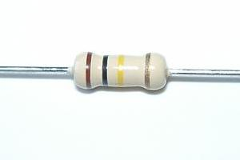

**Figure:2**

**2.3 LIGHT EMITTING DIODE:**

Light-emitting diodes, A light releasing diode is an electric component that emits light when the electric current flows through it. It is a light source based on semiconductors. When current passes through the LED, the electrons recombine with holes emitting light in the process. It is a specific type of diode having similar characteristics as the p-n junction diode. This means that an LED allows the flow of current in its forward direction while it blocks the flow in the reverse direction. Light-emitting diodes are built using a weak layer of heavily doped semiconductor material. Based on the semiconductor material used and the amount of doping, an LED will emit a colored light at a particular spectral wavelength when forward biased.

**USES OF LED**

LEDs find applications in various fields, including optical communication, alarm and security systems, remote-controlled operations, robotics, etc.

* Used for TV back-lighting
* Uses in displays
* Used in automotive
* LEDs used in the dimming of lights

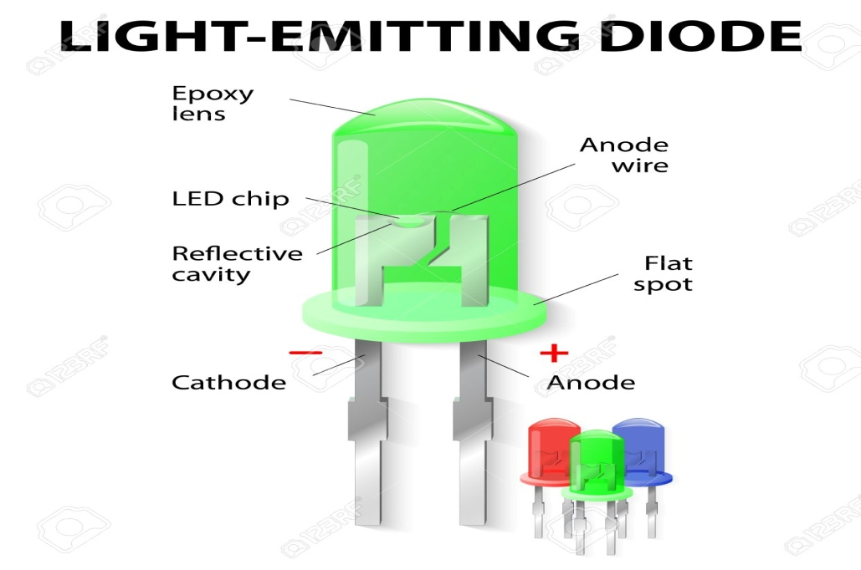

Figure: 3

**2.4 CAPACITOR:**

A capacitor is a device that stores electrical energy in an electric field. It is a passive electronic component with two terminals.

The effect of a capacitor is known as capacitance. While some capacitance exists between any two electrical conductors in proximity in a circuit, a capacitor is a component designed to add capacitance to a circuit. The capacitor was originally known as a condenser or condensator.

The physical form and construction of practical capacitors vary widely and many types of capacitor are in common use. Most capacitors contain at least two electrical conductors often in the form of metallic plates or surfaces separated by a dielectric medium. A conductor may be a foil, thin film, sintered bead of metal, or an electrolyte.

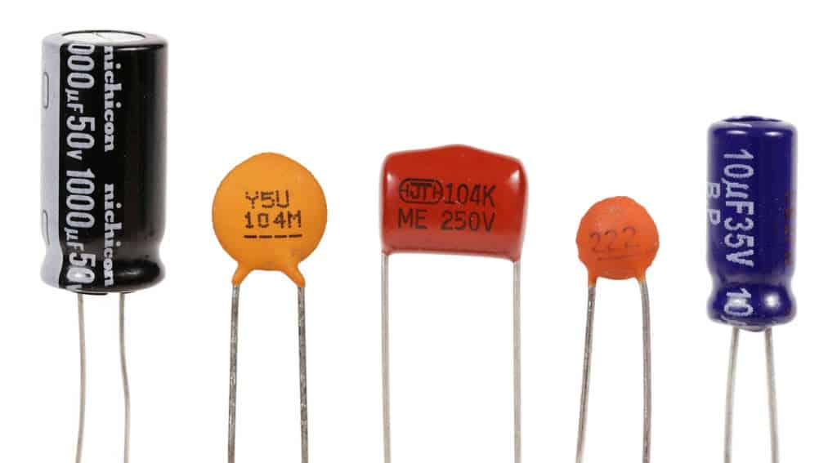

**Figure: 4**

**CHAPTER 3**

**Circuit diagram and Working Procedure**

**3.1 CIRCUIT DIAGRAM:**

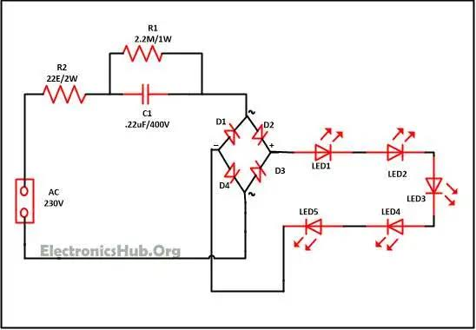

**Figure: 1**

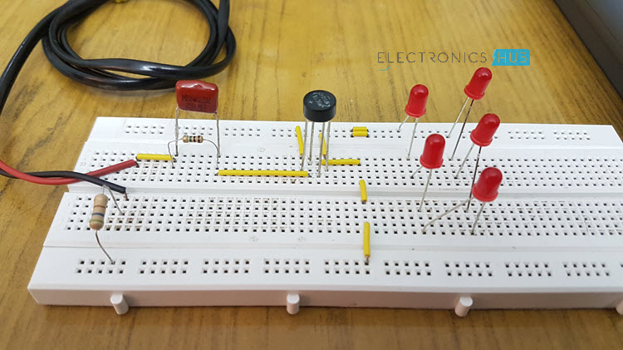

**3.2 WORKING**

**Working of Bridge Rectifier:**

The AC signal to be rectified is applied to the diagonally opposite ends of the bridge through the transformer. Between another two ends of the bridge, the load resistance RL is connected.

During positive half cycle of secondary voltage, the end P become positive and end Q negative. Thus Diode D1 and D3 will become forward bias and start conducting, while diode D2, D4 are reversed bias.

Diode D1 and D3 are in series with the load resistance RL hence current flows through RL. During negative half cycle of secondary voltage, the P end becomes negative and Q end become positive. Diode D2 and D4 are forward biased hence they start conducting. Whereas diode D1 and D3 are reversed biased.

Diode D2 and D4 are in series with the load resistor RL hence current flows through RL. It may be seen that again current flows from A to B through the load i.e. in the same direction as for the positive half cycle. Thus DC voltage is obtained across load RL. Output waveform of a bridge rectifier. The advantage of Bridge rectifier is that its output is higher than of full wave and half wave rectifier.

**Principle of led:**

Light emitting diodes are different from other diodes as they emit light and hence referred as light emitting diode. LED are available in RED, GREEN, BLUE color. An LED bulb produces light by passing the electric current through a semiconducting material—the diode—which then emits photons (light) through the principle of electroluminescence.

### 

**Figure: 2**

#### **Resistor**

All material has some type of opposition to the current flow. This opposition is called resistance. The resistance of a material is determine by the number of free electrons in the material. There is various type of resistor available such as carbon film, carbon composition, filament resistor and many more which can be used in an electronics or electrical circuit to determine the resistance.

Resistance of circuit depends upon p, L and A with the following equation.

R = p*(L/A)

#### **Capacitor**

The capacitor is a device that store electrical energy and capacitance is the amount of electrical energy stored at a given voltage drop by capacitor. A device specially designated to have a certain value of capacitance is called a capacitor. The capacitor has the ability to store electrons and release them at later stage. The capacitor is generally consist of two metal plate which are separated by a non conducting material called as dielectric.

#### **Diode**

Diode is an electronic device which allows current to flow only in one direction. Diodes are forward by joining N type and P type semiconductors. The N type semiconductor contains free electrons that move through the material. Similarly P type semiconductor contains holes. Electrons from the N type which are near the junction cross the junction and fill in the holes in P type material. Similarly holes near the junction of P type material, crosses the junction and occupy the place of electrons. A depletion layer is formed at the junction of the PN semiconductor.

### **Mains Operated LED Light Circuit Working:**

Working of circuit is very simple. Assemble the circuit properly as shown in circuit diagram. Now apply AC mains. Resistor R2 is used as current limiting component and resistor R1 is used with capacitor C1 so that it will discharge the capacitor which prevents lethal shock.

Now this power supply is provided to the bridge rectifier circuit which will convert the AC to DC and also reduces the voltage with the help of current limiting components. Now this power supply is passed to LEDs and the LED connected at the output start glowing. You can use bridge rectifier available in market or you can make your own with the help of four diodes. Maximum you can use up to 20 LEDs.

**OUTPUT:**

The output of this project is:

Typically, the forward voltage of an LED is between 1.8 and 3.3 volts. It varies by the color of the LED. A red LED typically drops around 1.7 to 2.0 volts, but since both voltage drop and light frequency increase with band gap, a blue LED may drop around 3 to 3.3 volts.

**CONCLUSION:**

This is a very simple and cost effective mains operated LED lamp which gives a very bright white light. Since no transformer is used, the circuit is very compact and light weight.

**CHAPTER 4**

**4.1 APPLICATONS AND ADVANTAGES**

### **Advantages of LED Bulbs**

* LED bulbs have 10 times longer life in comparison to fluorescent and incandescent lights.
* LED bulbs does not contain filament so there is less chances of damage.
* Common incandescent bulb become hot and generate lot of heat in the room while LED bulb prevents the heat buildup and helps in reducing the air conditioning cost in room.
* Power consumption of LED lamp is approx. 2-17 watt 1/3 in comparison to fluorescent lamp. So if you LED bulb you can save much on your electricity bill.
* Many people are using inverters in their home and now they are using LED lights with inverters because this will also increase the time period for which inverters can support LED light.

Applications of LED Bulbs

* High energy efficiency: LED lights are more efficient than standard fluorescent and incandescent lights
* Produce a long service life: LED light bulbs are designed to last up to 6 times longer than other types of lighting
* Controllability: LED lights are semiconductor devices that are able to be dimmed with controllers
* Available in a wide range of colors: LED lights come in a range of warmer or cooler lighting providing the ideal shade of light for any environment.

**CHAPTER 5**

**REFERENCES**

* wikipedia.com

Jacob Millman & Christos C. Halkias, Electronic Devices & Circuits, McGraw-

Hill, 1967 – Textbook

* http://www.fmlink.com/article.cgi?type=Magazine&pub=Premises%20&%20 Facilities%20Management&id=30856&mode=source
* http://www.circuitstoday.com/mains operated led light circuit
* http://www.ucl.ac.uk/estates/maintenance/fire/documents/UCLFire_TN_022.pdf
* http://en.wikipedia.org/wiki/Operated light
* https://www.scribd.com/doc/161102521/Mains-Operated led light ppt
* http://www.8051projects.net/files/public/1259220442_20766_FT0_7380969-line-follower-using-at89c51.pdf